SEO Metadata
- Focus Keyword: best digital marketing agency in Kolkata
- Meta Title: Best Digital Marketing Agency in Kolkata | Off-Page SEO Strategy | Brewing Ideaz
- Meta Description: Discover how Brewing Ideaz can build online visibility as a digital marketing agency in Kolkata through local citations, quality backlinks, guest posting, and brand awareness.
- URL Slug: /off-page-seo-best-digital-marketing-agency-in-kolkata/

Secondary Keywords
- digital marketing agency in Kolkata
- best digital marketing company in Kolkata
- digital marketing services in Kolkata
- online marketing agency Kolkata
- SEO agency in Kolkata
- performance marketing agency Kolkata
- social media marketing agency Kolkata
- digital marketing company Kolkata
- digital marketing experts in Kolkata
- Brewing Ideaz Kolkata

Off-Page SEO Strategy for the Best Digital Marketing Agency in Kolkata
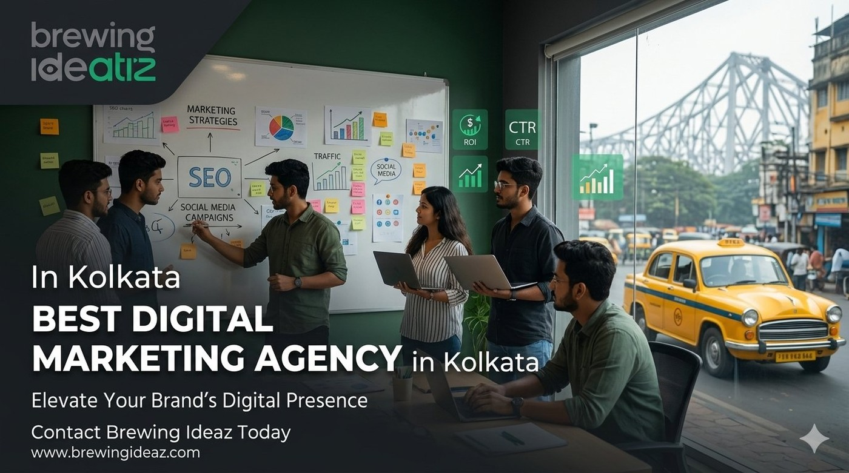
Building a strong online presence requires more than optimising a website. Off-page SEO helps businesses improve their online visibility, establish brand credibility, and build relevant connections across the web.
For businesses looking for the best digital marketing agency in Kolkata, a well-planned off-page SEO strategy can help improve brand discovery through local business listings, relevant backlinks, online mentions, and community engagement.

1. Google Business Profile (GBP) Optimisation
Weekly Google Business Profile Posts — publish regular updates sharing useful information about digital marketing services, industry insights, case studies, and business updates. Use relevant phrases naturally where appropriate.
Upload Relevant Business Images — team photos, office images, project results and campaign visuals, business-related event photos, relevant service-related graphics. Use accurate location information; avoid misleading location data.
Encourage Genuine Customer Reviews — request honest reviews describing real experience and outcomes. Do not offer incentives for positive reviews.
Maintain Consistent Business Information (NAP)
Kolkata Branch Office: D-66, Bangur Avenue, Kolkata, West Bengal 700055 Phone: +91 62915 47048 Email: info@brewingideaz.com

2. Local Citations and Business Directories
Recommended Directory Platforms: Justdial, Sulekha, IndiaMART, Clutch.co, Google Business Profile, Bing Places, relevant local business directories, relevant digital marketing and industry directories.
Citation Building Best Practices: use the correct business name, address, and phone number; add a clear and accurate business description; select the most relevant business category; include the official website URL; avoid creating duplicate listings; review listings periodically.

3. Backlink Building and Guest Posting Strategy
Target Platforms: YourStory, Medium, LinkedIn Articles, marketing blogs, startup and business blogs, local Kolkata and East India agency round-ups.

Guest Posting Topics
- How Businesses in Kolkata Can Improve Their Digital Marketing Strategy
- Local SEO Tips for Small Businesses in Kolkata
- Digital Marketing Trends for Startups in Kolkata
- How to Evaluate a Digital Marketing Agency
- Practical SEO Strategies for Growing Businesses

Anchor Text Strategy
- Branded anchors: Brewing Ideaz, Brewing Ideaz digital marketing
- Natural anchors: digital marketing services, learn more about digital marketing, visit the Brewing Ideaz website
- Relevant keyword variations: digital marketing agency in Kolkata, digital marketing solutions in Kolkata
Avoid forcing exact-match keywords into every backlink. Prioritise natural editorial placement and useful context.

4. Social Signals and Community Engagement
- LinkedIn: share useful industry insights, digital marketing tips, case studies, and blog summaries.
- X (Twitter): share short insights, blog highlights, marketing tips, and relevant updates.
- Reddit: r/Kolkata, r/indianstartups, r/marketing — contribute useful information and follow community rules.
- Facebook: engage with relevant Kolkata business owner, startup, and marketing communities.
- LinkedIn Carousel: how to evaluate a digital marketing agency; questions to ask before hiring an agency; common off-page SEO mistakes; practical digital marketing strategies for businesses.

5. Additional Off-Page SEO Tactics
Create Linkable Case Studies — turn genuine client results into detailed case studies covering challenge, strategy, implementation, and measurable outcomes.
Local Media Outreach — identify relevant Kolkata publications and business media outlets; pitch useful stories, expert commentary, and original insights.
Monitor Brand and Keyword Mentions — track mentions of Brewing Ideaz across relevant websites, blogs, and social platforms; engage or request a link when appropriate.
Build Relevant Industry Relationships — develop relationships with local businesses, industry communities, and relevant publishers through genuine collaboration.

6. Off-Page SEO Tracking and Performance Measurement
Metric | What to Track
Keyword rankings | Position changes for relevant Kolkata search terms
Referral traffic | Visitors arriving from external websites
Backlink profile | Relevant referring domains and link quality
Brand mentions | Mentions of Brewing Ideaz across websites and platforms
Google Business Profile insights | Available profile interactions and visibility metrics
Conversion data | Enquiries, calls, and other relevant business actions
Recommended Tracking Tools: Google Search Console, Google Analytics 4, Google Business Profile performance reports, a backlink analysis tool, a keyword rank-tracking tool.

Book Your Consultation With Brewing Ideaz
Ready to strengthen your online presence in Kolkata? Get in touch with our team to discuss your goals.
Brewing Ideaz
Phone: (+91) 62915 47048
Email: info@brewingideaz.com
Branch Office: D-66, Bangur Avenue, Kolkata, West Bengal 700055

30 Frequently Asked Questions About Digital Marketing Agency in Kolkata
- What is off-page SEO? Off-page SEO includes activities outside a website that help improve its visibility, reputation, and authority, such as backlinks, brand mentions, reviews, and local citations.
- Why is off-page SEO important for a digital marketing agency in Kolkata? It helps potential clients discover the business through relevant websites, local listings, referrals, and brand mentions.
- What is the best off-page SEO strategy for a digital marketing agency in Kolkata? A balanced strategy includes accurate local listings, relevant backlinks, useful content distribution, genuine customer reviews, and regular performance tracking.
- How does Google Business Profile help local businesses? It helps eligible businesses display accurate information and become discoverable through Google Search and Maps.
- Which directories can a Kolkata digital marketing agency use? Businesses can consider Google Business Profile, Bing Places, Justdial, Sulekha, IndiaMART, Clutch, and relevant industry directories, depending on eligibility.
- What is a backlink? A backlink is a link from another website that directs users to your website.
- How do backlinks help SEO? Relevant, editorially earned backlinks can help search engines discover pages and may contribute to authority and relevance signals.
- What is guest posting? Guest posting involves publishing useful content on another relevant website, often with an appropriate author or business reference.
- Where can a digital marketing agency publish guest articles? Agencies can explore relevant industry publications, startup websites, business blogs, and industry websites that accept useful contributions.
- What is anchor text? Anchor text is the clickable text in a hyperlink that describes or identifies the linked page.
- What anchor text should a digital marketing agency use? Use natural, descriptive, and branded anchor text rather than repeatedly forcing exact-match keywords into links.
- How important are social media shares for SEO? Social media shares can increase content exposure and attract visits or mentions, but they do not guarantee improved search rankings.
- Which social media platforms can a digital marketing agency use? LinkedIn, X, Facebook, and relevant online communities can help distribute content and connect with potential clients.
- How can a business get genuine client reviews? Ask clients politely for honest feedback after completing a project and follow the relevant platform’s review policies.
- What is NAP consistency in local SEO? NAP stands for Name, Address, and Phone number. Consistency helps customers and platforms identify the same business across listings.
- Can off-page SEO work without paid advertisements? Yes. Off-page SEO can focus on organic activities such as earning relevant backlinks, maintaining business listings, and sharing useful content.
- How long does off-page SEO take to show results? The timeline varies depending on competition, website history, implementation quality, and other factors. Results are not guaranteed within a specific period.
- What role does content play in off-page SEO? Useful content gives other websites and audiences a reason to reference, share, or discuss the business.
- Should blog images include the company logo? A relevant branded image can support brand recognition. The logo should be clear, and the image should match the article’s topic.
- How can off-page SEO performance be tracked? Google Search Console, analytics reports, business listing insights, and backlink monitoring tools can help track performance.
- Is off-page SEO only about backlinks? No. It can also include local citations, reviews, brand mentions, digital PR, and content outreach.
- Can local SEO be part of off-page SEO? Yes. Local listings, citations, and customer reviews are commonly included in local off-page SEO activities.
- How should a business choose guest-posting websites? Look for topical relevance, a genuine audience, editorial standards, and website credibility. Avoid link schemes.
- What is digital PR in SEO? Digital PR involves earning media coverage and brand mentions by sharing useful stories, research, expert insights, or resources with relevant publishers.
- How can brand awareness support SEO? Brand awareness may lead to more branded searches, website visits, mentions, and links, although results vary.
- Which tools are useful for off-page SEO? Google Search Console, analytics tools, backlink analysis platforms, and Google Business Profile insights can help monitor different aspects of performance.
- Do online reviews directly improve search rankings? Reviews can influence customer trust and local visibility, but rankings depend on multiple factors and are not guaranteed.
- What is a case study in digital marketing? A digital marketing case study explains a project’s objectives, strategy, execution, and verified outcomes.
- Can a Kolkata digital marketing agency get featured in local publications? Yes. An agency can pitch relevant stories, expertise, or project insights to local publications and business communities, though coverage is not guaranteed.
- How can I contact Brewing Ideaz for digital marketing services in Kolkata? You can contact Brewing Ideaz by calling or WhatsApping +91 62915 47048 or emailing info@brewingideaz.com to discuss your digital marketing requirements.

